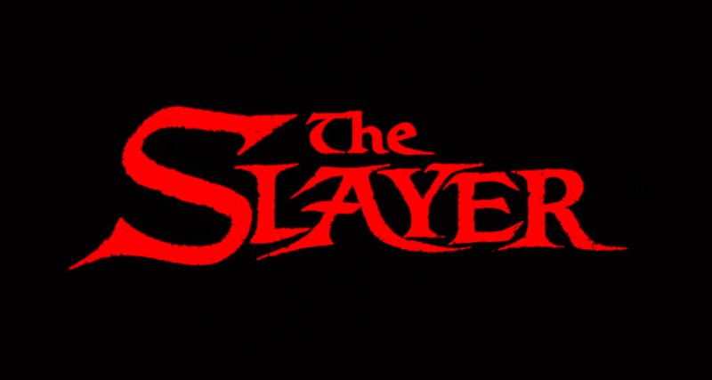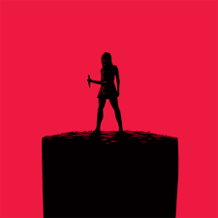

**Created by: Epik Kat**

**Artwork by: PawPrint Painter**

**Platforms: PlayStation, Xbox, Nintendo**

**Target Age: 10+**

**ESRB Rating: 10+**

**Release Date: TBA**

**Engine: Unreal Table Of Contents**

Game Outline……..Page 3

Characters……..Page 3-5

Gameplay…….Page 6-7

Game World….Page 7

Game Experience….Page 8

Gameplay Mechanics…Page 8-9

Enemies….Page 9-12

Multiplayer and Bonus Materials…..Page 12

Monetization…..Page 12

**GAME OUTLINE**You choose from two different alignments Good VS Evil and pick your own class. For Good you can decide on classes like The Slayer, Watcher, or Witch and for Evil you can pick from Vampire, Werewolf, or Demon. Once you have chosen your character you begin the game learning the basics of combat. You run around an open world defeating enemies and overcoming challenges. Your character can choose to go on quests destroying different groups of enemies, finding relics to further your goals in the game, or grind enemies to acquire money, items, armor or weapons and level your character. Some bosses or enemies will be difficult if you don’t acquire the right item or weapon in order to defeat them. As you progress through the game you will learn the lore of the Slayerverse and the many different characters and creatures of this world which you can use this knowledge to access areas that you wouldn’t normally be able to access. Victory in this game will require you to learn the lore, solve puzzles and quests, gain items, armor, weapons, and relics, defeat enemies and bosses, gain levels and increase your stats, become a stronger character and defeat the good or evil depending on your alignment. Save the universe from evil with your good character or destroy it with your evil character and become the ruler of the world.

**CHARACTERS**

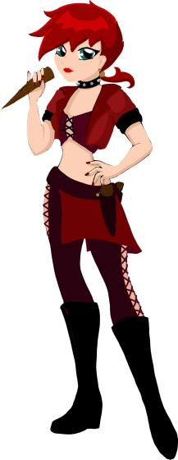

**Slayer:** Your character is an orphan who grows up in different foster homes through most of your young to teen years. Now that you have become of age you have memories flow through your mind and you try to come to an understanding of what your purpose is. You have strength and abilities you don’t understand not yet. You are one of the chosen ones to fight the evil in this world. You need guidance, support to help you understand your role in this world. An informal Watcher finds you after much searching. He will be your guide and your support through this journey.

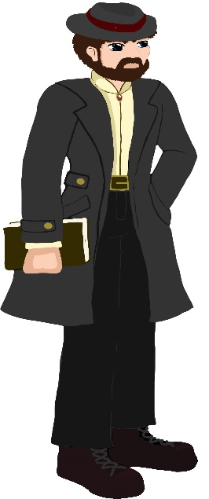**Watcher:** Most of the watchers were destroyed back in the hellmouth war 15 years ago. Those that survived have gathered and now try to continue on were their predecessors left off. They are a changed order though unlike the past watchers this new breed of watchers involve themselves in the battle more and fight alongside their beloved Slayers. Though there are more chosen ones then watchers they pick and choose people that have potential to carry on the duties of the watchers. You learn Magic’s, lore, demonology, fighting skills and techniques. Though you may not have the same strengths and abilities as the slayer or the intense Magic’s of the witches, you are still a formidable opponent. You train your body and mind to become tools to fight evil and support your slayer. Your knowledge of the cults, demonology, magic’s and lore will be essential in your quest to defeat evil.

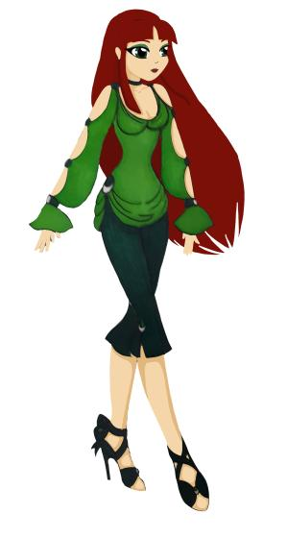

**Witch:** You are born a witch, raised in a Wiccan family. You come from a long lineage of witches. You have great potential and now that you have come to age you begin your trials to become a full fledge witch. You must learn magic, study spells and strengthen your control in the magic arts. You will learn defensive, attack and healing spells. Depending on which path you choose, it will decide the type of witch you will become.

**Vampire:** You find yourself waking up on a beach in the middle of the night. With no recollection of whom or what you are you search out for answers to your existence. You come across a small band of teenagers partying on the beach. They invite you to sit with them. You talk to the group and explain your situation. You begin to feel uneasy and sick to your stomach. You feel an unnerving need to feed. The happy partiers offer you some food but as you bite into it you automatically feel sick. Feeling more unsettling and that need growing you get anxious and agitated. One of the teenagers comes back from the water crying; apparently she scraped her arm on something unknown in the water. The moment you see the blood you seem to have no control over yourself and you instantly attack the person feeding on their open wound. They scream at you begging you to stop. As you feed one of the other teenagers tries to pull you off and you immediately without thought grab them by the throat and crush them like they were paper. The hunger in you is finally being fed and you end up killing the lot of them. After you have fed on their dead corpses you come to realize what you are.

**Werewolf:** You grew up in a large family who traditions were very different from the common world. You learn as you became older that your family are a species known as Lycanthropus Exterus also known as werewolves. However while werewolves can have children the children themselves do not become werewolves just on genetics. There is a trial the young ones must go on to take on the mantle of becoming a werewolf. Most don’t survive the trials, for the young ones are left in the forest and have to defend themselves against their own family. If you pass the test and survive you then are welcomed into the family by being bit by one of the elders. You passed this test and know have become a lycan however the traditions put humans on the bottom of the food chain.

**Demon**: Demons come in all shapes, sizes, forms, and powers. You can choose which type of demon you wish to be. You’re all derived from a hellmouth and have no love for humans, other than for your pure enjoyment and their pure torture. You are big, powerful, and evil, the world is yours to conquer.

**CHARACTER CONTROLS**

PS4

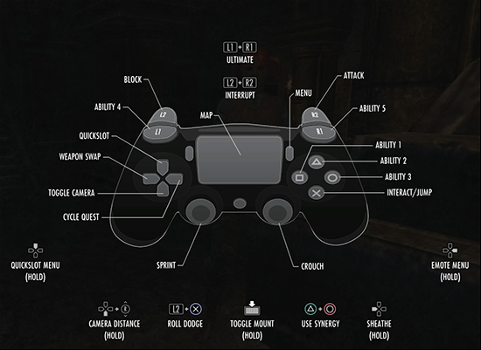

Xbox One

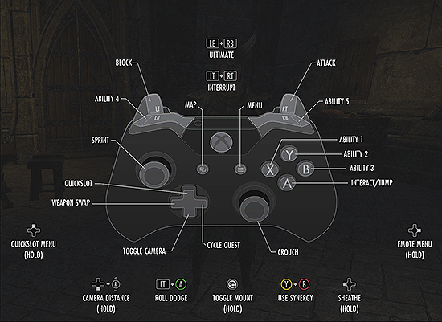

**GAMEPLAY**

Story mode teaches you the fundamentals of the game while you level up and become the best slayer or demon you can be. It gradually helps you become accustomed to learning on how to use your moves, learn new techniques and gives a good level of storytelling for the character you choose. When story mode is completed it’s not the end of the game, you will have a more defined character to take on online mode and show the world how much you have learned. Or if you just feel like strapping on the slayer mantle and going straight to online mode battling hordes of monsters , Enemy players and teaming up with a few friends for a well-rounded adventure. Are you an Evil character that sick of getting your butt kicked by the good guys or are you a good character that’s bored of always killing demons over and over again well don’t worry you can choose to change your alignment. You will have to go through some gruelling tests to prove that you’re no longer the evil incarnate or goodie-two shoes you once were. However you only get one chance to change it so decide wisely and maybe you can finally fall in love with that hot vampire you’ve been seeing around that you just can never seem to kill. Need some training or just need a bit of time away from killing baddies then why not train or test your skills in the Hero Trials. Go one on one against other slayers, witches, or watchers and prove your skills. Sick of running away from the righteous ones then why don’t you sit back relax and watch the Blood Dome, where demon, vampires and monsters fight against one another to see who really the demon king is.

**GAME WORLD**

Beaches, Forest, Farms, Graveyards, Parks, Town, City, Mountains, Suburbs, Tombs, Hellmouth, School, Warehouses, Harbour, Valley, Desert, Sewers, Stores, Clubs/Bars,

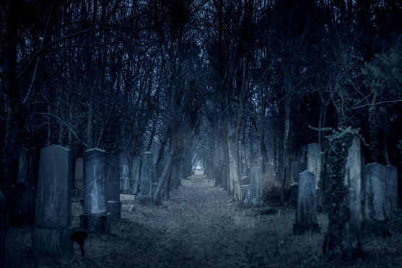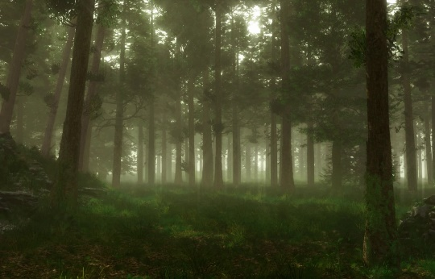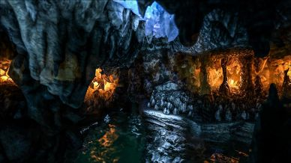

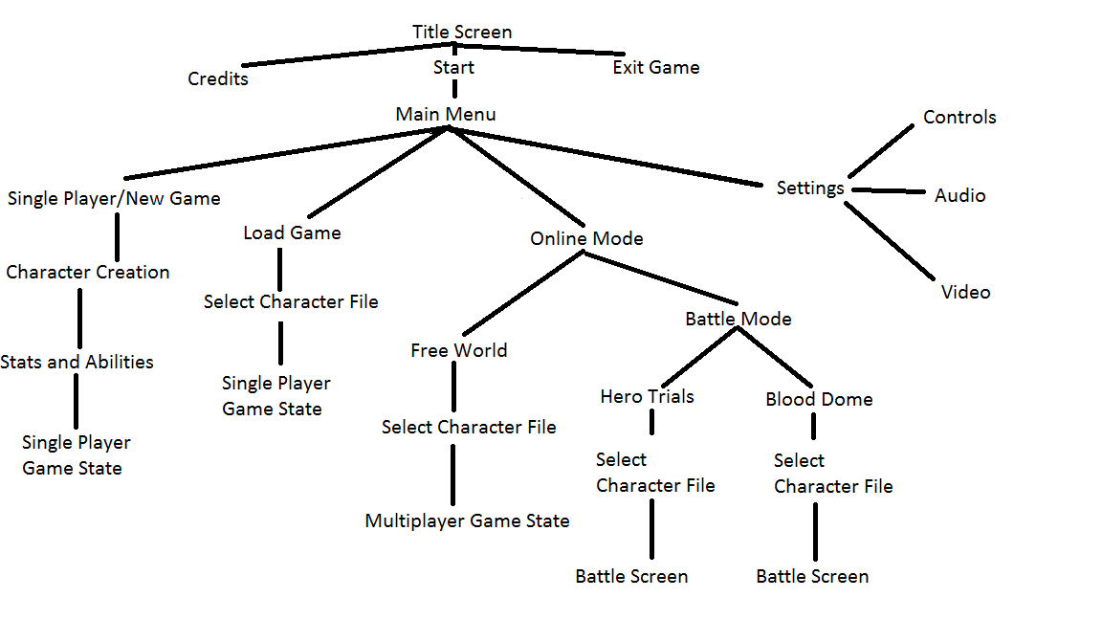**GAME EXPERIENCE**

When players first start the game depending on which class of character they chose they will get to see a cut scene with their own designed character giving a little bit of history on the characters back story. Fear and excitement will be the mood we will try to create for the player. Using some licensed music from the buffyverse and our own composed music/sound to give the game an eerie ambience. When adventuring the music will be slow and subtle but when attacked it will turn into intense battle music. Some enemies will use jump scare tactics to excite the player. I would compare the sounds and music closely related to the ones you would hear in Bloodborne or Dark Souls.

**GAME MECHANICS**

The player controls their character in a 3D world exploring, adventuring battling against AI enemies which will give the player experience upon defeating each one. The player can accumulate experience points to use on stats and abilities and level increasing. Each level the player gains gives them more access to abilities for their own specific class. Players can buy with game coins (collected from each enemy they kill) different armor, weapons, styles of clothes, items, etc.

Players can also find items, relics, armor, or weapons when either killing enemies, destroying objects (fences, garbage cans, bushes, tombstones, etc.) completing quests/sub-quests, or Killing Bosses.

Depending on your character class there are many elements that your character could be hurt or perish from. There are some things that one character could be hurt by that another could cause no affect. However some examples of these would be drowning, majority of the classes could all perish from drowning except for vampires. Fire however harms everyone. Electricity has effect on characters. Falling into pits or falling down a cliff could badly damage some character classes while others could shrug it off. Lack of oxygen or suffocating can affect some classes.

There will be certain hidden gems that you would really have to look for in order to collect them. Each character would be able to find and gather little artifact’s that would tell them stories about certain buffy characters. They wouldn’t have no real impact on the game unless you collect them all which could lead to a bonus or unlock a special character for you in game.

**ENEMIES**

**Bosses**

Each class will come across a specific boss that they will have to fight.

For the Slayer they will have to fight against a Master Vampire. This Master will be larger then regular vampires and also have more abilities. You will have to fight him through 3 stages first stage is just him in his first form which will be a mist and he will have multiple vampires that you will have to fight off will attempting to attack him. He will go back and fourth between his normal form and the mist form and you have to time it right to attack him when he’s whole. His second stage/form will be of a Giant Bat. T defeat this form you will have to use ranged weapons like your crossbow. The masters final from will be reverted to a giant version of himself more grotesque then his normal form. To defeat him you will need to use a holy relic to stun him then attack him using stakes.

For the Witch you will have to take on a powerful Necromancer. Using your ranged and healing spells you will have to defend against his awesome power. The necromancer will occasionally summon zombies to distract you from attacking him directly. Fire and healing will be your greatest powers against him. Using a healing spell will take the most damage on the necromancer while fire will set the zombies on fire and make them run into him damaging and stunning him for a few seconds.

For the watcher you will take on an old classic type of monster a sort of Frankenstein type. A monster made of parts from corpses. He was created by the Necromancer and is quite powerful compared all other undead creatures. For the watcher to defeat this enemy you will have to use protection spells to hold him in place while you try to hack him a apart piece by piece. You have to focus your physical attacks on certain body parts (each part will have its own health bar) Use your swiftness and cunning to defeat this Boss.

For the demon’s Boss you will take on a powerful Holy Knight. He will be armed with not only brute strength but also holy magic. To dismantle the Holy Knight you will have to (much like the Frankenstein monster) attack different parts of his holy armor until all of the armor is destroyed allowing you to attack his flesh and cutting his health bar down. Using eternal flame on his open flesh will give you an advantage at slicing him down.

For the werewolf your boss will be against an experienced and trained hunter. He was raised by hunters and his only path in life is to wipe out all werewolves. He will be strong, quick and resourceful. He attacks with a lot of melee attacks but does have some ranged weapons mostly silver arrows shot from his crossbow. His ultimate attack is calling upon other hunters who pop out of the bushes and surround you shooting arrows. If you’re quick enough you can avoid this attack but it has a small escape point and if landed it will mortally hurt you or kill you right off. To fight off this great hunter you will have to be defensive and quick. If you’re able to use a bite attack on him it will be used to your advantage for it will slowly deplete his health bar. However you only have a very small attack window to pull of this move so you have to be quick and cunning. Claws, teeth, and brute force are your keys to wiping this hunter from existence. But if your bite depletes his health first he will turn into the thing he hates most. Then you will have to fight him in this second stage with tooth and claw. During this stage though the hunters that were with him during his ultimate attack will now shoot you both constantly till whichever one dies first. Make sure you survive long enough.

Now for the vampire’s boss. You will be fighting an experienced slayer from the past(if we get licensing I was hoping to get a well known slayer not buffy cause we cant kill buffy off but maybe Faith) This slayer will throw everything she has at you. Starting with crossbows and switching to an axe and the occasional stake she will do everything she can to take you out. She will use her crossbow till it runs out of arrows and when that stage is over she will attack you head on with an axe. You must dodge and use your vampire sense and speed to out maneuver. She will use her ultimate attack using her stakes. Using two at close combat if you get caught she will dust you in a blink but if you dodge it and keep beating her health down you will get the chance to rip out the slayers throat and feed on her corpse.

**AI Enemies**

Zombies, Vampires, Demons, werewolves, soldiers, hunters, Holy Order(knights, clerics), witches, humans, Fairies, Warlocks, robots,. There will be multiple types of enemies depending on environment and locations. Each with specific health bar, weaknesses and strengths.

**MULTIPLAYER and BONUSES**

There will be bonus material and lore you can find through out the game. Relics will open tidbits of information from Buffy the vampire slayer. If you find a certain amount you can unlock cameo characters that can interact with you through out the game. You can complete side quests from these characters and get powerful relics from the old buffy days. Their will be multiple achievements from everything like killing a 100 vampires or killing the most humans. Scoring these will give you more percentage on completing the game to a 100%.

This game is very much Multiplayer. You can play single player but you get so much more awards when you play in a group or if you play one of the fighting modes against other players. For multiplayer you can have up to 6 people per party. In fighting mode you can tag team battle with a friend.

**MONETIZATION**

You buy the game as a whole and DLC is free. In the future depending on positive feedback and sales we can discuss future content that will be purchasable. For example new classes and more areas. We could sell DL content but only in the form of clothing styles different hair styles or body types, different gestures but nothing that would affect the game play like pay to win types.